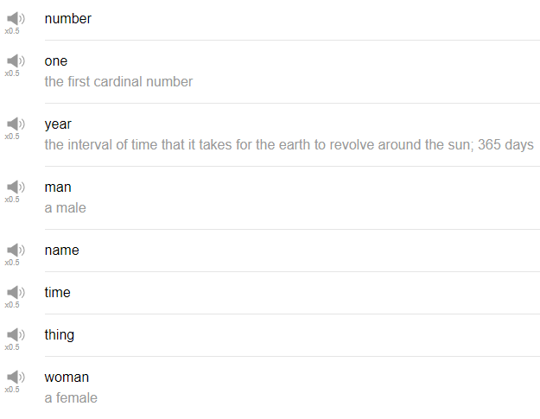

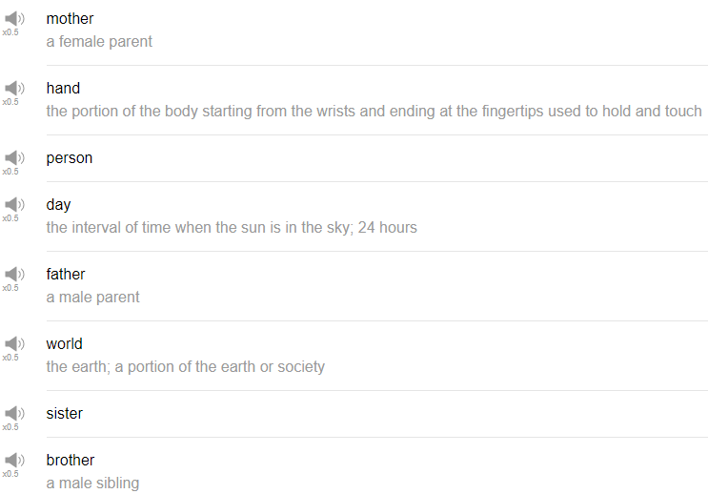

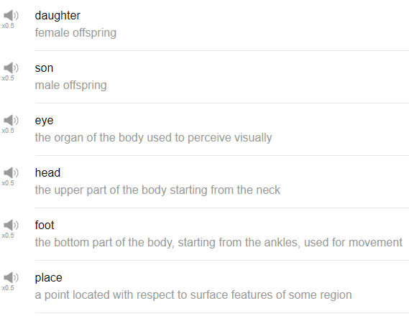

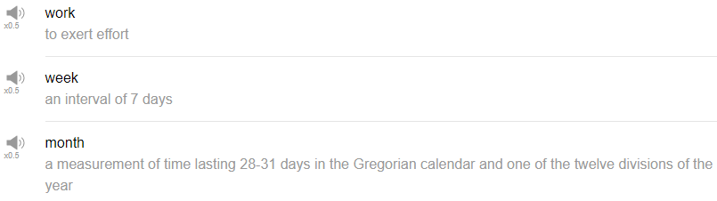

|  |
| --- |
| Hi everybody, my name is Alisha and today we are going to be talking about the top 25 English nouns. These are the top 25 most commonly used nouns in English. So let’s get started! |
| 1. The first noun is the word “name”. |
| Name of course is used in common questions like “What’s your name?” “My name is…” and so on. |
| My favorite actor’s name is Harrison Ford or something like that. |
| Say my name, say my name. |
| 2. The next word is “time”. |
| Time is used of course to express the point in the day and it’s used in questions like “what time is it?”, “can you tell me what time it is?” |
| “I don’t have any time lately”, if you are really busy. |
| Have you any time? |
| It’s time for my favorite show House of Cards. Kevin Spacey is cool. |
| 3. And the next noun is “man”. |
| Please be careful, man is one of those words that has an irregular plural form. When you need to use the plural of the word man, you should say men, do not say mans. It’s very funny but don’t say it. |
| Who is that man or what’s up man? You can use man with men or women interestingly enough. |
| 4. The next word is “woman” |
| And woman also has an irregular plural form. Please say women when referring to more than one woman, not womens or womans. Even though the singular and the plural form of women and woman have the same spelling at the beginning wom, the pronunciations are different, woman, women. So watch out for that when you say this. Pretty woman! |
| 5. The next word is “person”. |
| You can use it to refer generally to either a man or a woman. Please be careful. Person’s plural form becomes people. When you want to talk about another culture for example, you can say such and such country’s people or the people in that country speak blah blah blah language. |
| 6. The next word is “thing”. |
| Generally an inanimate object, something that just doesn’t move like a water bottle or you know sweater, a thing. You can use it when you don’t know the word for something. So thing is very, very useful. |
| What is this thing? I like many things, for example. |
| Where the Wild Things Are is a movie that’s already out that I totally knew about. |
| 7. The next word is “mother”. |
| Mother is the person, the woman who gave birth to you. Isn’t that exciting? |
| Mother is commonly shortened to mom or mama or mommy, ma, madre if you speak Spanish, mamba if you are me, mamasita. |
| 8. The next word is “day”. |
| Of course day is used in all of the days of the week, Monday, Tuesday, Wednesday, Thursday, Friday, Saturday, Sunday. Time period when the sun is out, the day or the day time. Have a nice day. |
| 9. The next word is “world”. |
| World just refers to the entire planet earth. Well I like to travel all around the world or I like trying foods from all around the world. In the world of science, this is an upcoming technology; or in the world of literature, he is one of the most famous authors. So world can be used to refer just to kind of a more specific hobby or a specific interest or just a specific person’s life. War of Worlds. |
| 10. “Father”, father is your ‘dad’. |
| Other common words used for father are dad, papa, pop, daddy, pa, fasher. I use that one with my dad. |
| While mother is used to refer to kind of like nurturing kind of, like you know, the earth or things that like kind of give life to others. Father at least in my mind, there is kind of this image of someone who is a little bit more strict in your life. |
| 11. The next word is “sister”. |
| A female sibling is your sister and you can also use sister for a female person that you feel very, very close with. So I might call my female friend who is – I am very close to, my sister. My brother likes to shorten it to sis. You might also hear sista as well if you are silly. Sister, Whoopi Goldberg was in a famous movie called Sister Act. |
| 12. The next word is “brother”. |
| Brother is a male sibling. You can also use brother to refer to a close male friend, common variations of brother are brother, bro, brah, broski depending on what kind of person you are, you can choose to use any number of those like I might sarcastically say to my friend, “cool story bro” like, if you just told me a story that’s not very exciting. |
| In Mario for example, the name of the Mario game is actually Super Mario Brothers but brothers is abbreviated as Bros, Super Mario Bros. Yeah just be careful about your use of bro because it sounds a little bit like a college age boy. That’s kind of a feeling of the word bro. |
| O Brother Where Art Thou? |
| 13. The next word is “daughter”. |
| Daughter is a female child, daughter. Do you have a daughter, I have a daughter, I don’t have a daughter. Taken! |
| 14. It’s “son”. |
| A male child is someone’s son. Son is pronounced exactly the same as Sun. |
| What are you talking about, son? |
| 15. The next word is “eye”. |
| Your eye is the round thing that you use to see with. Eye is used in a lot of expressions and idioms in English as in I’ve got my eye on you meaning I am watching you; or keep your eye out for something, meaning please look for something, or please pay close attention. I am waiting for something to happen. |
| 16. The next word is “hand”, body part. |
| Give me a hand, or can I give you a hand? It means please help me, or can I help you? To give someone a hand. |
| 17. “Head”, this thing on the top of your body, your head. |
| We use head to refer to the top of things as in the head of a company, the head of a group, the head of the line, so whoever is first in the line, whoever is top at the company, they are the head. If you have a head, dance. If you have a head, then dance uh! |
| 18. The next word is “foot”. |
| This is another word that has a weird plural form. One foot, two feet. Foot interestingly enough, foot is used of course to refer to your body part. A foot also is a unit of measurement if you are from America or I believe one other country in the world uses this system. Sorry we are not on board with a metric thing in America but foot is 12 inches, about this long. So if head refers to the top of things, foot is used to refer to the bottom of things. If you’ve written a paper on Microsoft word for example, at the very bottom of the page, there will be a space called the footer meaning the bottom where you can put little notes to your reader. |
| 19. The next word is “place”. |
| Place can be used to refer generally to a location commonly to refer to friends homes or apartments. |
| Let’s go to your place or can we have the party at your place? |
| It's a little bit more natural than I want to go to your house. |
| 20. The next word is “work”. |
| Be careful about using work as a noun and work as a verb. Your work refers to your job, your responsibilities, your tasks at your office or your workplace. You can use it in a phrase like “I have a lot of work to do” or “please help me with my work”. I like to go to work. It can be used to just refer to anything artistic in general. So it can mean, it can be a painting, it can be a building, it can be a sculpture, it can be arrows, whatever. Anything artsy can be referred to as work as in I really like that new work by that artist or did you see so and so’s new work? |
| Twerk? |
| 21. The next word is “week”. |
| Week refers to the 7-day period that we have decided is one week here in the modern world. Commonly used in expressions relating to your activities as in I go to the gym once a week or I see my friends twice a week or I have to work every day of the week. Monday through Friday is referred to as weekdays. Saturday and Sunday weekend. |
| 22. Next word is “month”. |
| Month is, there are 12 months in a year. |
| My favorite month depending on which country I am in, I generally like autumn months like October. I think I usually like the month of October. September-October is good because it’s not too hot and not too cold and Halloween is coming and that’s my favorite holiday. Hannah "Month"tana. |
| 23. Next word is “year.” |
| Year refers to the time period usually 365 days. There are leap years where there is an extra day in the month of February. |
| “What year were you born?” or “I was born in the year of the rabbit” depending on which calendar you like to use. |
| It can be used to introduce a story, as in many years ago, I went to blah, blah, blah. |
| Year of the platypus. |
| 24. Next is the word “one”. |
| The number one, the first number, one of something, to refer to somebody who you loved and who left your life, you can say, oh he or she was the one that got away. |
| 25. The next one is the “number”. |
| but it can be used in a number of expressions, like, “what’s your phone number?” or “give me your number” or “here is my number”. It means phone number but we don’t always say phone. |
| That’s the end of the top 25 most common nouns in the English language. Maybe you’ve used some of these. We probably have. Keep them in mind and have fun with them. Thanks very much for watching this episode and we will see you again soon, bye. |